Lab 3
Composition & Polymorphism

Consider the following class hierarchy:

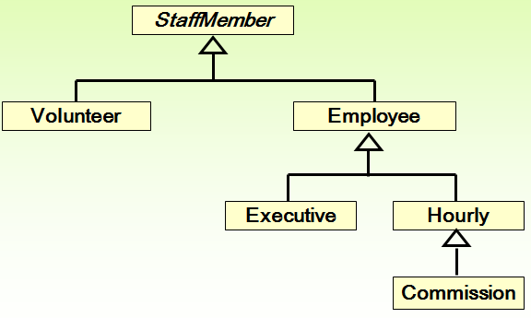

StaffMember Class

- Create an abstract class called StaffMember, with protected String member variables name, address and phone number.
- The constructor should require values for all variables.
- Override the toString() method to display the details of the member variables.
- Create an abstract pay() method that returns a value of type double.

Volunteer Class
- Create a class called Volunteer with no new member variables.
- Create a suitable constructor with parameters.
- Override the pay() method to return 0 pay for a volunteer.

Employee Class
- Create a class called Employee with 2 additional member variables rsiNumber (private String) and rate of pay (protected double). The rate of pay in this class represents the actual salary.
- Create a suitable constructor with parameters.
- Override the toString() method to display appropriate data for this class.
- Override the pay() method to return the pay rate.

Hourly Class
- Create a class called Hourly with 1 additional member variable for hours worked (private integer).
- Create a suitable constructor with parameters that initialises appropriate variables and sets the hours worked to 0.
- Create an addHours() method which takes 1 parameter representing the number of hours worked and uses this to update the hours worked.
- Override the pay() method to return the payment due. Hourly employees are paid by the hour and receive overtime pay (i.e., 1.5 times their hourly salary rate) for all hours worked in excess of 40 hours.
- Override the toString() method to display appropriate data for this class.

Executive Class
- Create a class called Executive with 1 additional member variable to represent a bonus (private double).
- Create a suitable constructor with parameters that initialises appropriate variables and sets the bonus to 0.
- Create an awardBonus() method which takes 1 parameter representing the amount of the bonus and uses this to update the bonus.
- Override the pay() method to return the payment due. This amount should also include the bonus.

Commission Class
- Create a class called Commission with 2 additional private member variables total sales and commission rate (double).
- Create a suitable constructor with parameters that initialises all appropriate variables (total sales can be assigned to 0).
- Create an addSales() method which takes 1 parameter representing the amount of sales achieved and uses this to update the sales.
- Override the pay() method to return the payment due. This amount should also include the commission. The commission is the (totalsales*commission rate)
- Override the toString() method to display appropriate data for this class.
Staff Class
- Create a class called Staff with 1 member variable (array of type StaffMember).
- Create a default constructor which takes no parameters. Inside the constructor you have to create 8 staff member objects and initialise them with the data shown below.
Use an initialiser list e.g.
staffList = new StaffMember[]{new Executive("John", "1 This St", "0874323476", "R6574635", 2423.07), new Employee(…..), etc}

Type of Staff member | Name | Address | Phone Number | RSI Number | Rate of Pay | Comm Rate
Executive | John | 1 This St | 0874323476 | R6574635 | 2423.07
Employee | Paul | 2 That St | 0854345222 | P8884635 | 1246.15
Employee | Dave | 3 Other St | 0864343566 | S9876635 | 1169.23
Hourly | Joanne | 4 Long Ave. | 0836789676 | T0987635 | 10.55
Volunteer | Norma | 5 Short Ave. | 0864323456
Volunteer | Kate | 6 Pecks Lane | 0854676767
Commission | Molly | 7 Nowhere Rd. | 0864326789 | L6599635 | 6.25 | .2
Commission | Joe | 8 My Place | 0864344545 | G8888635 | 9.75 | .15

- Create a processStaff() method that uses a for loop to go through the collection and call the methods awardBonus(), addHours(), addSales() to perform the 4 operations shown below. You should call these methods inside the same for loop but you may need to do some casting.

    - Award a bonus of €500 to John
    - Joanne works 50 hours
    - Molly works 55 hours and she has sales of €400
    - Joe works 45 hours and he has sales of €950

- Create a payday() method that displays the appropriate amount of pay for each staff member. Again you need a for loop here to go through the collection, implicitly call toString() and call the pay() method.

TestCompany Class
Create a test class which should create a Staff object and call the processStaff() and payday() methods. Note, the test class has just 3 lines of code.
Test Data
Name: John
Address: 1 This St
Phone: 0874323476
RSI Number: R6574635
Paid: €2,923.07
-----------------------------------
Name: Paul
Address: 2 That St
Phone: 0854345222
RSI Number: P8884635
Paid: €1,246.15
-----------------------------------
Name: Dave
Address: 3 Other St
Phone: 0864343566
RSI Number: S9876635
Paid: €1,169.23
-----------------------------------
Name: Joanne
Address: 4 Long Ave.
Phone: 0836789676
RSI Number: T0987635
Current hours: 50
Paid: €580.25
-----------------------------------
Name: Norma
Address: 5 Short Ave.
Phone: 0864323456
Thanks!
-----------------------------------
Name: kate
Address: 6 Pecks Lane
Phone: 0854676767
Thanks!
-----------------------------------
Name: Molly
Address: 7 Nowhere Rd.
Phone: 0864326789
RSI Number: L6599635
Current hours: 55
Total sales: 400.0
Paid: €470.63
-----------------------------------
Name: Joe
Address: 8 My Place
Phone: 0864344545
RSI Number: G8888635
Current hours: 45
Total sales: 950.0
Paid: €605.63
-----------------------------------

